Daniel Spencer Parlier
WVFS Tallahassee
Seminole Productions
Courtney Mitchell
Valerie Segebre
Hispanic Marketing
Public Relations
Amy Stevens

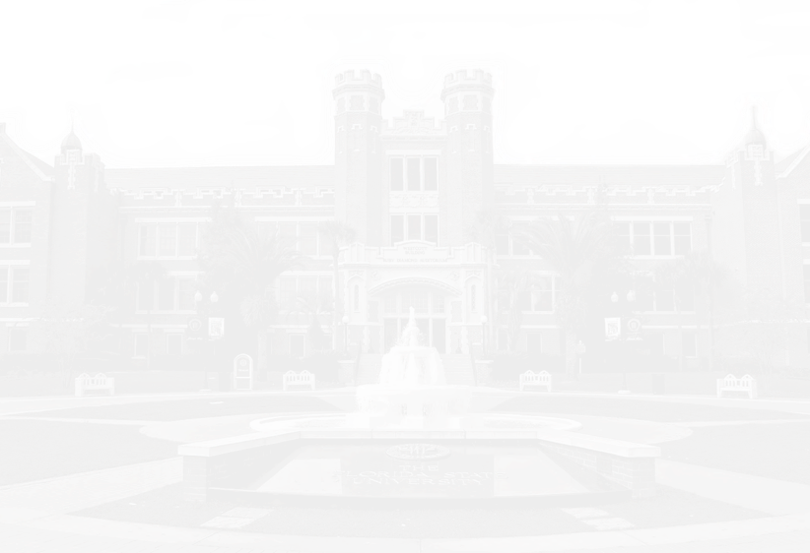
Honors Recognition
Friday, April 6th Two Thousand Eighteen
Miller Hall University Center Building C
3:30 - 5:30 PM
Honoring community partners, faculty, alumni and students from the School of Communication Science and Disorders, School of Information, and School of Communication
Political Representation in Pakistan
Faculty Mentor- Dr. Stephen McDowell
The U.S. v. Pakistani Media Portrayal of Women’s
Mariapia Rueda
Social Media Efects on Social Capital
Faculty Mentor- Dr. Patrick Merle
Stephanie Mancuso
Episodic and Thematic Framing Efects on Immigration Attitudes
Faculty Mentor- Dr. Patrick Merle
Anna Gabriela Garcia
and Political News Source
Faculty Mentor- Dr. Patrick Merle
An Investigation of Relative Hostile Media Efect
School of Communication
Megan Comunale
During Speech Production
Faculty Mentor- Megan MacPherson, Ph.D.
The Efect of Cognitive Load on Lip Movement
Kendra Stebbins
Exploring the Role of a Church in the Growth and Development of Children with ASD
Faculty Mentor- Juliann Woods, Ph.D.
Rachel Sinclair
Vowels Sung by Classically Trained Male Singers
Faculty Mentor- Richard Morris, Ph.D.
Glottal Cycle of Open and Closed Head Voice
Bailey Rosenbalm
Production and Perception of English Spoken by Native Speakers of Korean
Faculty Mentor- Richard Morris, Ph.D.
Leslie Novakovic
Severe Dysarthric Speech
Faculty Mentor- Kaitlin Lansford, Ph.D.
Efects of Perceptual Training in Listeners of
Atiana McBride-Tobiere
Comparing Naming Speed in the Arabic and English Productions by Bilingual Speakers Using Syllables/Second
Faculty Mentor- Richard Morris, Ph.D.
Olivia Emerson
Relationship Between Vocabularly Knowledge and Morphological Awareness
Faculty Mentor- Carla Wood, Ph.D.
School of Communication Science and Disorders
Nicole Baldauf
HONORS IN THE MAJOR
CEREMONY & RECEPTION
JB Barnes-Mitchell Roger Batlle Kaitlyn Bludau
Susan Brosnan-Maddox Gary Burnett
Megan Choutupalli Jessica Felsen Emily Franco Michelle Laurents Natalie Marcelo
Howard Rodriguez Mori Cassie Nicolace Ellen Nimmons Christie Petruzelli Krissa Robinson Stephanie Vivirito
CCI HelpDesk
SPECIAL THANKS

CONNECT WITH US

/CCIFSU

@fsu_cci
@FSUCCI

Addlyn Teague
Gene T. Sherron Award
Outstanding Undergraduate Student Awards
Outstanding Undergraduate IT Student
Allison Cannan
Frances Vallario Taylor
Outstanding MSIT Student
F. William Summers Outstanding MLIS Student
Simone Clunie
Tyler Smith
Digital Media Production
Master’s Teaching Assistant SPC 1017
Julia Hix
Master’s Teaching Assistant SPC 2608
Alessandra Noli
Doctoral Research Award
Jerrica Rowlett
Hispanic Marketing Student
Nivia Escobar Salazar
Extraordinary Service Award
Matilda Von Kalm
Outstanding Undergraduate Student Awards
Advertising
Victoria Villanti
Media Communication Studies
Chelsi Chang
Alessandra Noli
Outstanding Doctoral Teaching Assistant
Olivia Bravo
Master’s Teaching Assistant
Xabier Climent Belda
Outstanding Master’s in IMC Division
Oustanding Graduate Student Awards
Outstanding Doctoral Student
Joshua Hendrickse
Outstanding Master’s in MCS Division
Tabitha Rose Cervantes
AWARDS
SCHOOL OF COMMUNICATION
Dr. Sindy Chapa
Faculty Leadership/Builder Award
Faculty Teaching Award
Dr. Andy Opel
Lisa Martin-Owens
Outstanding Distance Learning Student (2017)
Marissa Arrington
Outstanding Graduate Assistant Awards
Dana DiAntonio and Sarah Johnson
Outstanding Undergraduate Student Awards
Outstanding Undergraduate Student (Senior)
Loren Stoller
Outstanding Undergraduate Student (Junior)
Kathleen Cofey
Outstanding Distance Learning Student (2016)
2nd Year Clinician
Matthew McCloskey
1st Year Clinician
Paige Wadsworth
Caterina Gabriella Demoya
1st Year Master’s Student
Oustanding Graduate Student Awards
Outstanding Doctoral Student
Abby Delehanty
2nd Year Master’s Students
Sarah King and Taryn Johnson
AWARDS
SCIENCE AND DISORDERS
SCHOOL OF COMMUNICATION
Outstanding Doctoral Graduate Teaching Assistant
Curtis Shane Tenney
Outstanding Graduate Lead Instructor
Crystal Dawn Betts-Green
Oustanding Graduate Student Awards
Outstanding Doctoral Student
Ana Ndumu
Outstanding Doctoral Research Award
Biyang Yu
AWARDS
SCHOOL OF INFORMATION
Kelly Marie Miller
School of Communication
School of Communication Science and Disorders
Anna Layne Evans
School of Information
Brittany Hope
COUNCIL LEADERSHIP AWARDS
CCI STUDENT LEADERSHIP
Faculty Research Award
Dr. Jaejin Lee and Dr. Art Raney
School of Communication
Dr. Kathleen Burnett and Leila Gibradze
Faculty Leadership/Builder Award
Faculty Research Award
Dr. Marcia Mardis and Dr. Yolanda Rankin
Faculty Teaching Award
Dr. Lynne Hinnant
School of Information
Dr. Leonard “Chick” LaPointe
Faculty Leadership/Builder Award
Disorders
Faculty Research Award
Dr. Carla Wood
Faculty Teaching Award
Dr. Selena Snowden
School of Communication Science and
FACULTY RECOGNITION AWARDS
Mariapia Rueda
School of Communication
Ana Ndumu
School of Information

FSU Academic Leadership Undergraduate Student
FSU Academic Leadership Graduate Student
Mackenzie Nicole Bowlin
School of Communication Science and Disorders
FSU President’s Humanitarian of the Year
UNIVERSITY AWARDS
John Cantú
School of Communication
School of Communication Science and Disorders
Dr. Alliete Alfano
School of Information
Ryan Miller
CCI DISTINGUISHED ALUMNI
The Children’s Campaign
School of Communication
Division of Library and Information
Services - FL Department of State
School of Information
Tallahassee Memorial Rehabilitation
Center
School of Communication Science and Disorders
COMMUNITY PARTNERS
CCI DISTINGUISHED
Arrowhead Advertising
School of Communication
American Library Association (ALA)
Student Chapter
School of Communication Science and Disorders
Student Audiology Association
School of Information
AWARDS
CCI STUDENT ORGANIZATION
School of Communication Science and Disorders Graduate Award: Katherine Kopystanski Undergraduate Award: Atiana McBride- Tobiere
School of Information
Undergraduate Award: Jade Reppenhagen
CCI LEADERSHIP AWARDS
Teaching Faculty, IT Program Chair
Dr. Mark Jowett
PRESIDING
Dean, College of Communication and Information
Dr. Lawrence Dennis
WELCOME
School of Communication
Graduate Award: Maria Puente
Undergraduate Award: Kelly Marie Miller

